**Sleep EEG Data Project Report**

1. **Introduction:**

This report is to explore and analyse the whole night sleep data which were provided by the laboratory from Dr. Mary Carskadon.

The sleep data consist of four subjects. For each subject, there is a baseline night (BSL) of rested sleep and a recovery night following sleep deprivation (REC). The data were stored as the .*npz* file form, there are 3 keys: *DATA*, *srate*, and *stages* in the file.

The DATA info including eye movements (detected by electrooculography, EOG), muscle tone (detected by electromyography, EMG), and neural activity (detected by EEG). There are 9 channels in total:

* EEG Channels: Channel 1: C3/A2, Channel 2: O2/A1, Channel 8: C4/A1,Channel 9: O1/A2
* EOG Channels: Channel 3: ROC/A2, Channel 4: LOC/A1
* EMG Channels: Channel 5: Chin EMG 1, Channel 6: Chin EMG 2, Channel 7: Chin EMG 3

The sleep activities are classified as different stages as the epoch of 30s. The classification scheme is as follows:

* 7 - Unscored (typically before lights out or after lights on, not analyzed)
* 0 - Awake
* 1 - NREM Stage 1
* 2 - NREM Stage 2
* 3 - NREM Stage 3
* 4 - NREM Stage 4
* 5 - REM Sleep
* 6 - Movement Time

1. **Exploratory analysis**

The data analysis starts from the exploratory analysis, which including: input raw data visualization, data Hypnogram graph and epoch average power spectrum density (PSD) spectrum.

1. Data visualization:

As the first step, we can make a plot of input data. Form the loading data, we already have the data sampling rate, so the data time point can get from: *np.arange(len(data[0]))/np.float(rate)*.

With *plt.plot()* function, the data plotting can be gotten as:

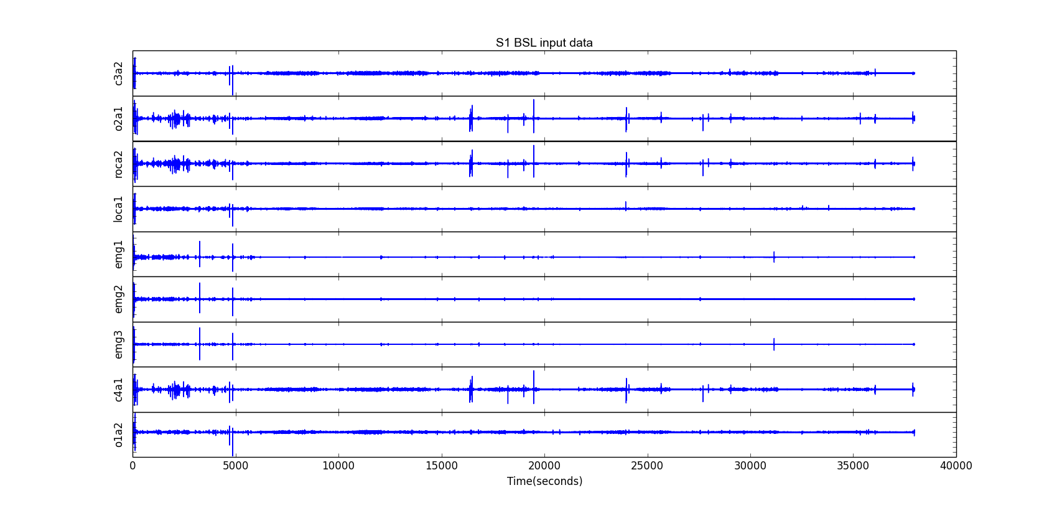

Above, just showing the ‘s1_bsl.npz’ dataset, other dataset’s plottings are similar.

1. Hypnogram

Hypnograms are useful tools to visualize how sleep stages change throughout the night. Researchers classify sleep in 30 second epochs based on criteria original standardize by Rectshaffen and Kales in 19681 and revised by the American Academy of Sleep Medicine (AASM) in 20072. This process is often completed manually.

In this step, the input dataset’s hypnograms and their classified night activities stages are plotted. The plotting follow the approaching in problem set 4 assignment. The resulting plotting is as follows. Similar to the data visualization, only the result from ‘s1_bsl.npz’ dataset is shown.

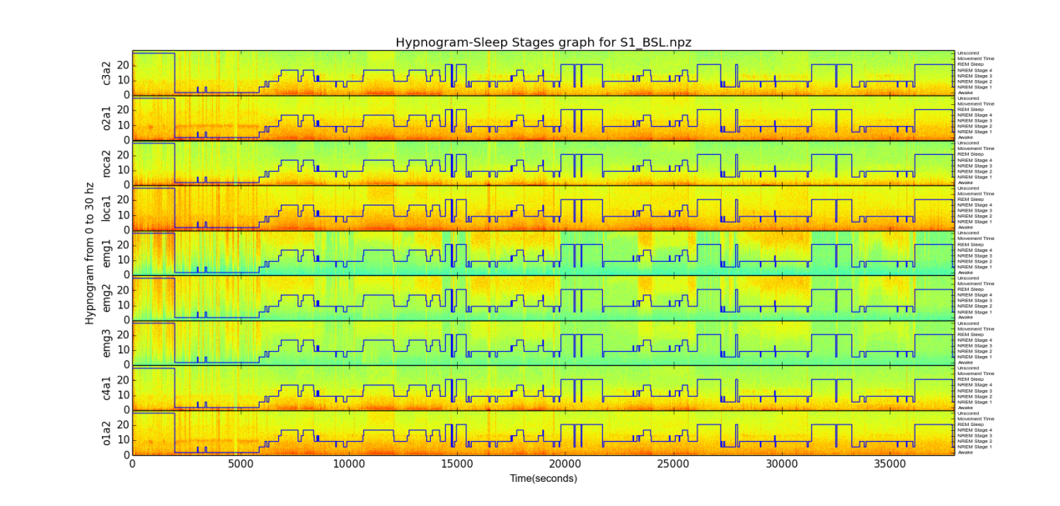

1. PSD spectrum

One target of this project is to explore and further develop the night activities classifier which started from assignment 4. The classifier is based on input dataset’s PSD spectrum. The idea in here is that different epochs are classified as the different stages, so there should be some common characteristic between different epochs but are classified as the same stage.

The PSD spectrum exploration is try to show the difference between different activity stages. The actual plotting is based on average PSD of same classified stage epochs in the same data set. The reason for this that from observation, we can see that for a set of objects which share some common features, the cumulation can strength their common feature, and lessen their variances.

The PSD plot is as follows, where only ‘s1_bsl.npz’ dataset’s Awake, NREM stage1 and NREM stage 2 are shown, other graphs are similar.

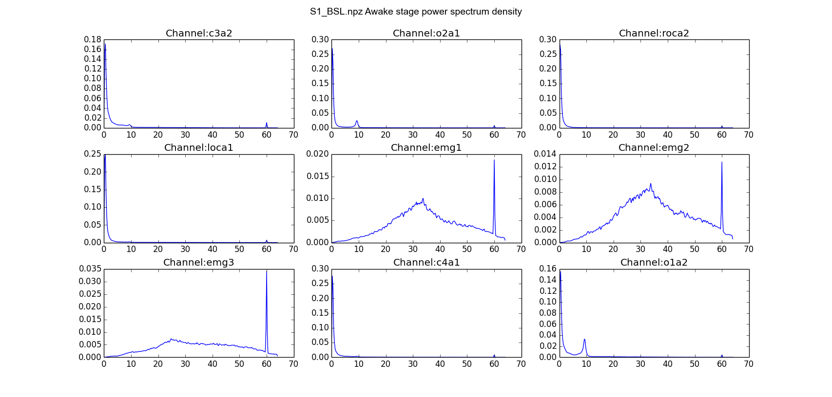

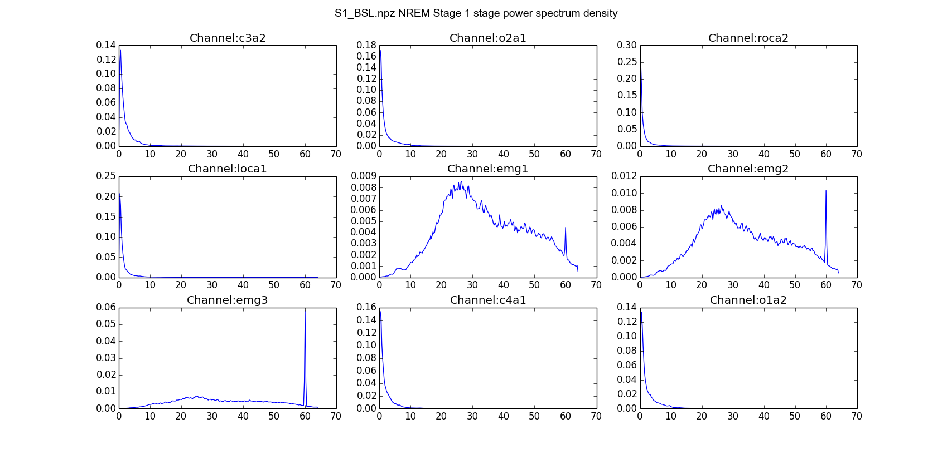

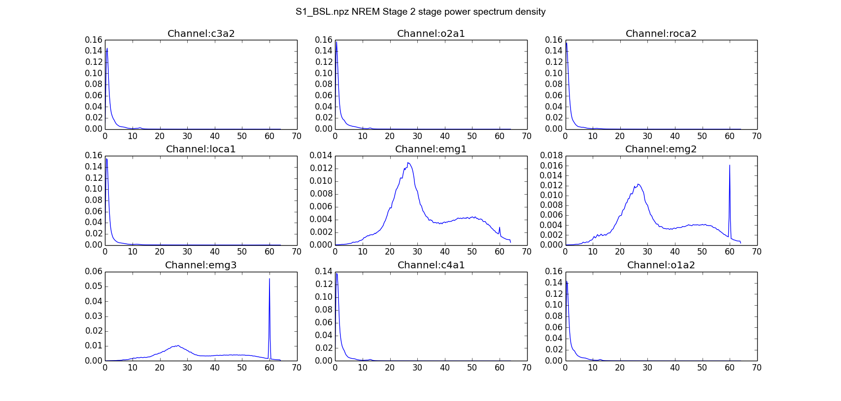

1. **Sleep stages**
2. Stages steps-wise and histogram

One question in this project is try to show how difference of sleep stages change between the well-rested night and the sleep-deprived night.

Similar to above approach, as the first step, we can explore the sleep stages in different conditions with the step-wise plotting and histogram plotting as follows:

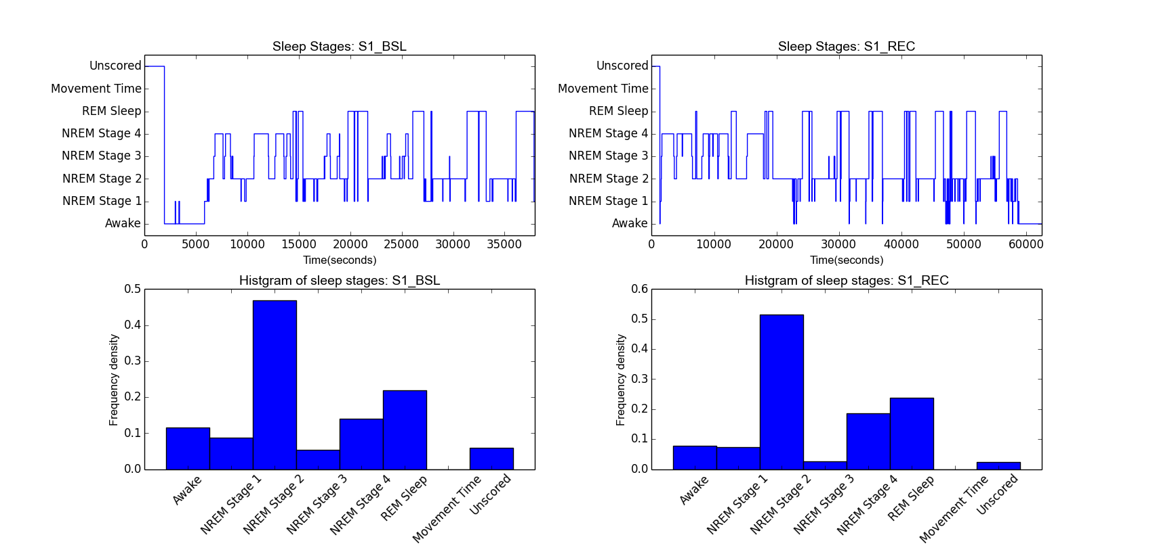

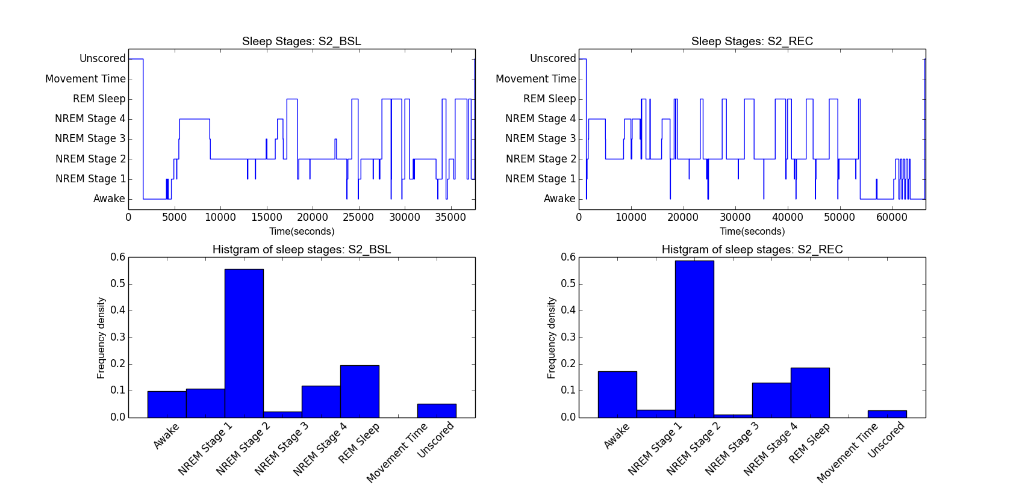

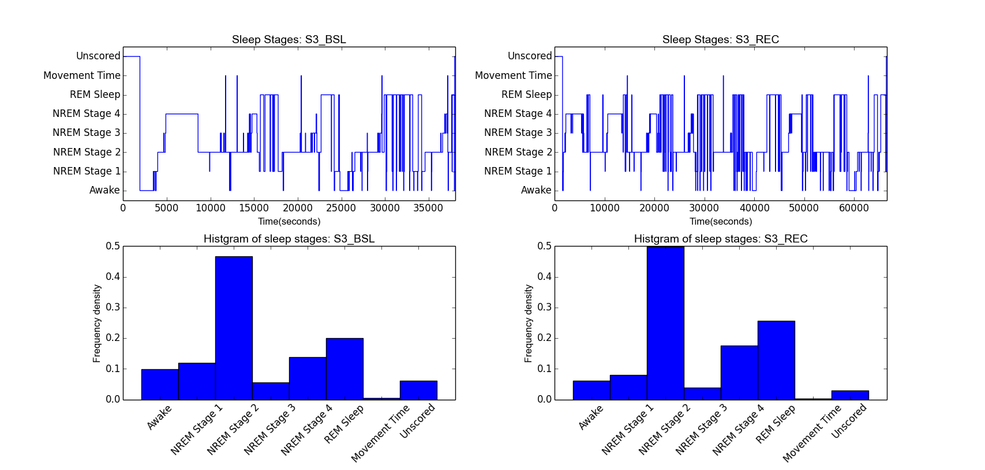

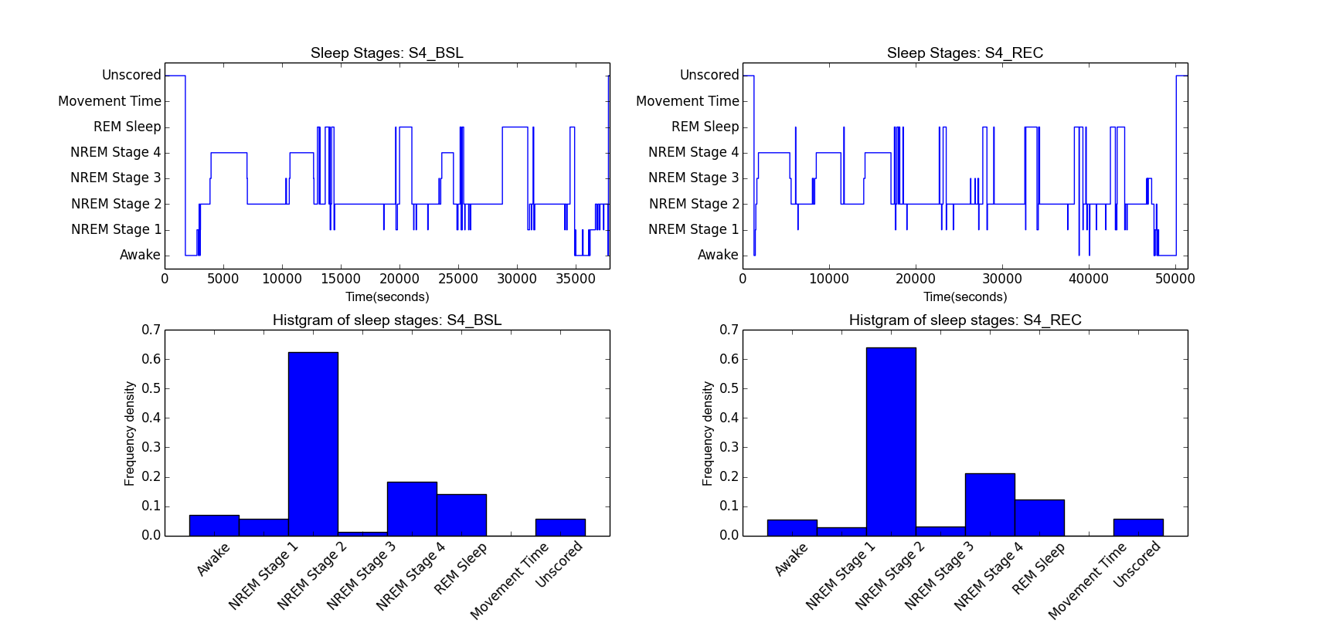

1. Kolmogorov-Smirnov statistic statistics test:

From previous section’s sleep stages graph exploration, we can observe some difference between the well-rest sleep and the restore from the deprivation sleep. In this section, we will use Kolmogorov-Simirnov testing to test if this observation is true.

The Kolmogorov-Smirnov test can be used to decide if a sample comes from a population with a specific distribution. It is based on the empirical distribution function (ECDF).The two-sample K–S test is one of the most useful and general nonparametric methods for comparing two samples. In python, the function - *stats.ks_2samp()* function can be used for K-S testing. It returns a K-S statistics and a p-value. The testing resulting is:

|  |  |  |  |  |
| --- | --- | --- | --- | --- |
| Subject | S1 | S2 | S3 | S4 |
| P-Value | 0.0952597707058 | 0.00175801799348 | 0.00170569764169 | .246317742994 |

For subjects S2 and S3, K-S testing p-value smaller than 0.05. It shows we can assume there are difference sleep stages distribution between well-rest sleep and restoring from deprivation sleep.

For subject S1 and S4, the p-values are greater than 0.05, so we cannot assume there are statics difference between well-rest sleep and restoring sleep.

1. **Activities classification**

Now, we can further explore the night activities classifier for the given datasets. The classifier is based on the python ‘*sklearn*’ module. The data set is the previous explored epoch PSD spectrum.

In the implementation, the whole data sets were divided into the 80% training set and 20% testing set. The SVM, KNN, Decision tree, Randomforest and Naive Bayes methods were used in training, while Randomforest shown one of the best performances. So the final results just show the result from Randomforest.

For training strategies, one-vs-rest and normal training are implemented. The classification correctness is show in below:

|  |  |  |  |  |  |  |  |  |  |
| --- | --- | --- | --- | --- | --- | --- | --- | --- | --- |
|  | c3a2 | o2a1 | roca2 | loca1 | emg1 | emg2 | emg3 | c4a1 | o1a2 |
| OvR_S1_BSL | 0.787 | 0.748 | 0.718 | 0.728 | 0.658 | 0.678 | 0.683 | 0.752 | 0.752 |
| MS_S1_BSL | 0.792 | 0.757 | 0.738 | 0.708 | 0.653 | 0.678 | 0.678 | 0.772 | 0.757 |
| OvR_S1_REC | 0.829 | 0.820 | 0.793 | 0.790 | 0.730 | 0.742 | 0.694 | 0.706 | 0.838 |
| MS_S1_REC | 0.832 | 0.817 | 0.796 | 0.787 | 0.721 | 0.745 | 0.718 | 0.721 | 0.829 |
| OvR_S2_BSL | 0.825 | 0.785 | 0.785 | 0.8 | 0.785 | 0.76 | 0.805 | 0.82 | 0.79 |
| MS_S2_BSL | 0.825 | 0.785 | 0.785 | 0.795 | 0.775 | 0.765 | 0.8 | 0.83 | 0.79 |
| OvR_S2_REC | 0.879 | 0.867 | 0.850 | 0.864 | 0.751 | 0.732 | 0.715 | 0.881 | 0.907 |
| MS_S2_REC | 0.881 | 0.859 | 0.847 | 0.867 | 0.743 | 0.737 | 0.706 | 0.884 | 0.907 |
| OvR_S3_BSL | 0.498 | 0.591 | 0.532 | 0.502 | 0.463 | 0.532 | 0.537 | 0.542 | 0.512 |
| MS_S3_BSL | 0.488 | 0.567 | 0.547 | 0.502 | 0.458 | 0.557 | 0.542 | 0.542 | 0.507 |
| OvR_S3_REC | 0.482 | 0.518 | 0.535 | 0.510 | 0.535 | 0.583 | 0.530 | 0.510 | 0.532 |
| MS_S3_REC | 0.496 | 0.535 | 0.544 | 0.515 | 0.532 | 0.572 | 0.535 | 0.501 | 0.541 |
| OvR_S4_BSL | 0.644 | 0.668 | 0.668 | 0.668 | 0.733 | 0.748 | 0.688 | 0.629 | 0.658 |
| MS_S4_BSL | 0.644 | 0.649 | 0.678 | 0.663 | 0.733 | 0.738 | 0.703 | 0.634 | 0.673 |
| OvR_S4_REC | 0.755 | 0.785 | 0.781 | 0.770 | 0.730 | 0.726 | 0.720 | 0.803 | 0.781 |
| MS_S4_REC | 0.748 | 0.785 | 0.777 | 0.774 | 0.730 | 0.726 | 0.723 | 0.807 | 0.774 |

From above results, we can see that overall, the OvR strategies have a better performance than the non-strategies approach, but the difference is not too much.

For different subjects, S1 and S2 have the general good classification results. The subject S4’s classification result is accept. But the subject S3’s results are pretty poor(correctness are around 0.5). To show what’s wrong, let’s check the PSD of S3: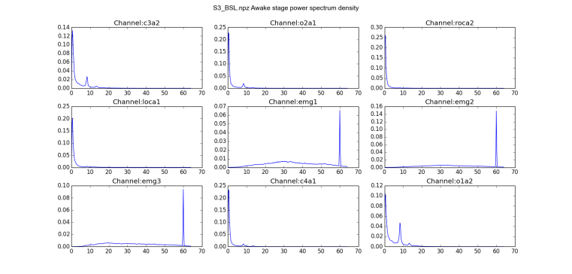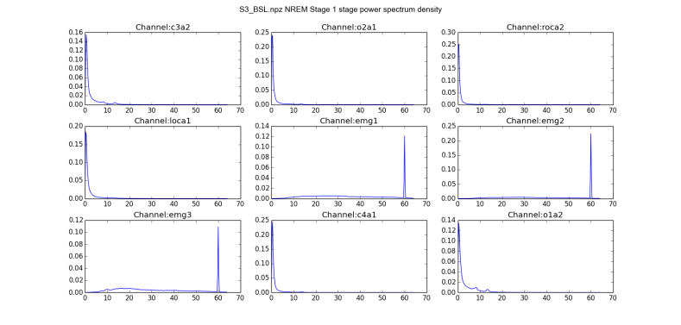

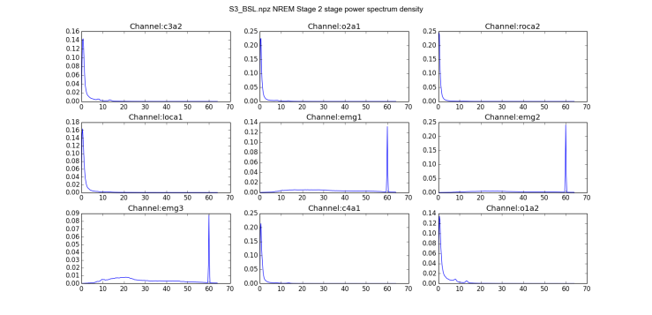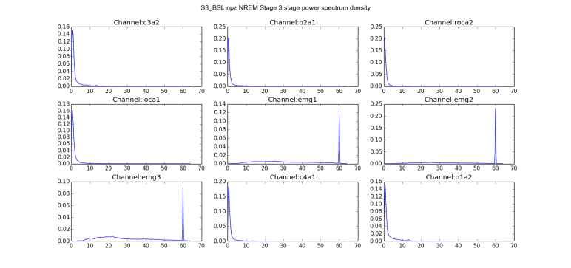

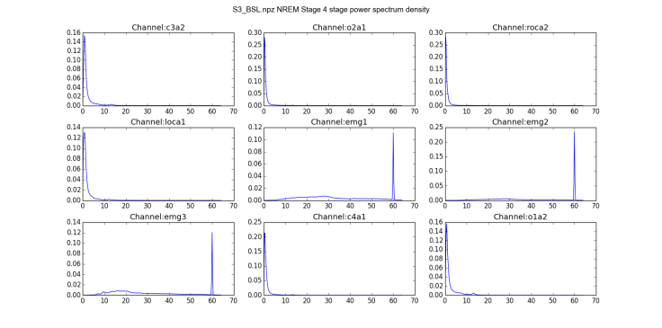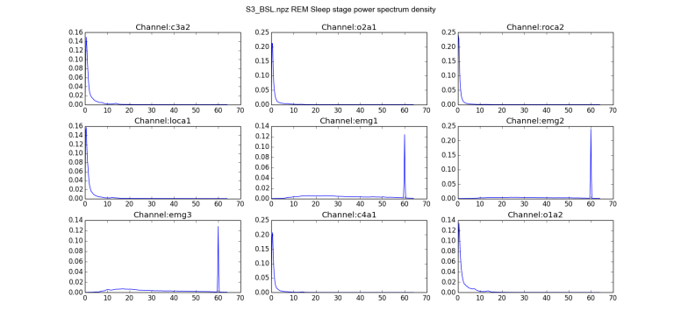

Observing above PSD spectrum, we can see that except the ‘Wake’ stage, all the PSDs from sleep stages, NREM 1/2/3/4 and REM, are very close. Just from the eye-sight observation, it’s very hard to find the noticeable difference. This should be the reason why the classification is so poor.

1. **Conclusion**

In this project, the exploration analysis for the whole night sleep from Dr. Mary Carskadon was made. The exploration include the data visualization, hypnogram plotting, PSD spectrum plotting. From these exploration results, the sleep stages distributions were compared between the well-rest night and restoring from deprivation night were compared. It shows in subject ‘S2’ and ‘S4’, there is statistic noticeable difference, but in subject ‘S1’ and ‘S4’, there isn’t statistics noticeable difference between well-rest sleep and restoring sleep.

Finally, with python module ‘*sklearn*’, based on the PSD spectrum, a sleep stages classifier was explored. The classification results for the subject ‘S1’,’S2’ and ‘S4’ are acceptable, but subject ‘S3’’s results were poor. The further analysis shows that there isn’t noticeable difference in PSD between ‘S3’’s NREM 1/2/3/4 and REM stages. The root reason for this will be studying in future.

1. **References**
2. “Sleep EEG Data Project Data from the laboratory of Dr. Mary Carskadon”: Exploring Neural Data course material
3. “ Problem Set 4: Sleep Stages and Hypnograms”: Exploring Neural Data course material
4. Kolmogorov–Smirnov test: <http://en.wikipedia.org/wiki/Kolmogorov%E2%80%93Smirnov_test>